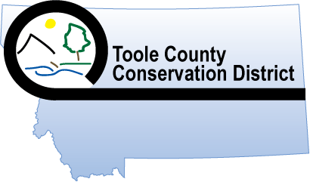
Toole County Conservation District
1125 Oilfield Avenue, Shelby, MT 59474
(406) 434-5234 ext. 4
toolecounty59474cdf@gmail.com

MEETING MINUTES
AUGUST 8, 2023
Call to Order: Roger Smedsrud calls meeting to order at 6:05pm.
Quorum present: Roger Smedsrud – Chairman, Robert Aklestad
Others present: Cindy Florez – TCCD Administrator
Approve agenda: *We will host the Area III Meeting in 2024. I will take minutes for Area III meeting on Wednesday September 27th 2023 in Choteau. Big Sandy will take our minutes in 2024.
*At Area III meeting see if other CD counties want to trade county map booklets.
*Included is the report from north and central Montana CD. We should wait on the Resolution it looks like it is something that is already going to happen. Prioritizing Money for CD employees. Read report.
*We made updates on the Conservation District Directory 2024.
*We will buy two Soil Moisture Probes from Amazon.
*We filled out Report to North Central Montana Conservation Districts.
*Ask Thad White to attend the September TCCD meeting. We want to discuss the money left from Range Days.
*We cleaned out the storage shed.
Minutes: *Robert Aklestad motion to Approve and sign July 11th minutes.
*Roger Smedsrud second.
*Motion carries.
Treasurer’s Report: *Robert Aklestad motion to approve Treasurer’s Report.
*Roger Smedsrud second.
*Motion carries.
*Roger Smedsrud motion to pay all bills.
*Robert Aklestad second.
*Motion carries.
Bills to Pay *Visa $258.24 (paid)
*Leavitt’s Great West Insurance $3,269.00 (paid)
*Computer $1,757.52 (paid w/Visa)
Standing Reports:
Maps: (1) Toole, (6) Toole Wall, (3) Glacier, (4) Pondera, (5) Liberty
*Roger Smedsrud motion to buy (6) Toole County Map Booklets.
*Robert Aklestad second.
*Motion carries.
NRCS:
FSA:
FWP:
MSU Extension:
Old Business: *We now have the Policy book for Liability Insurance with Leavitt Great West of Shelby.
New Business:
Correspondence:
Announcements: *Area III Meeting September 27th at the Stage Stop Inn in Choteau. Registration will be sent shortly.
*MCDEO 2023 SET Training in Fort Peck, MT August 27-29.
*Fall Convention 2023 November 14-16. (We will reserve 6 rooms)
Next Meeting: *September 12, 2023 at 6pm.
- APPROVED SIGNATURE__________________________

- APPROVED SIGNATURE__________________________

- ADMINISTRATOR_______________________________

